Communities and bio-cultural diversity in Cambodia—
options for policies and action whose time has come!

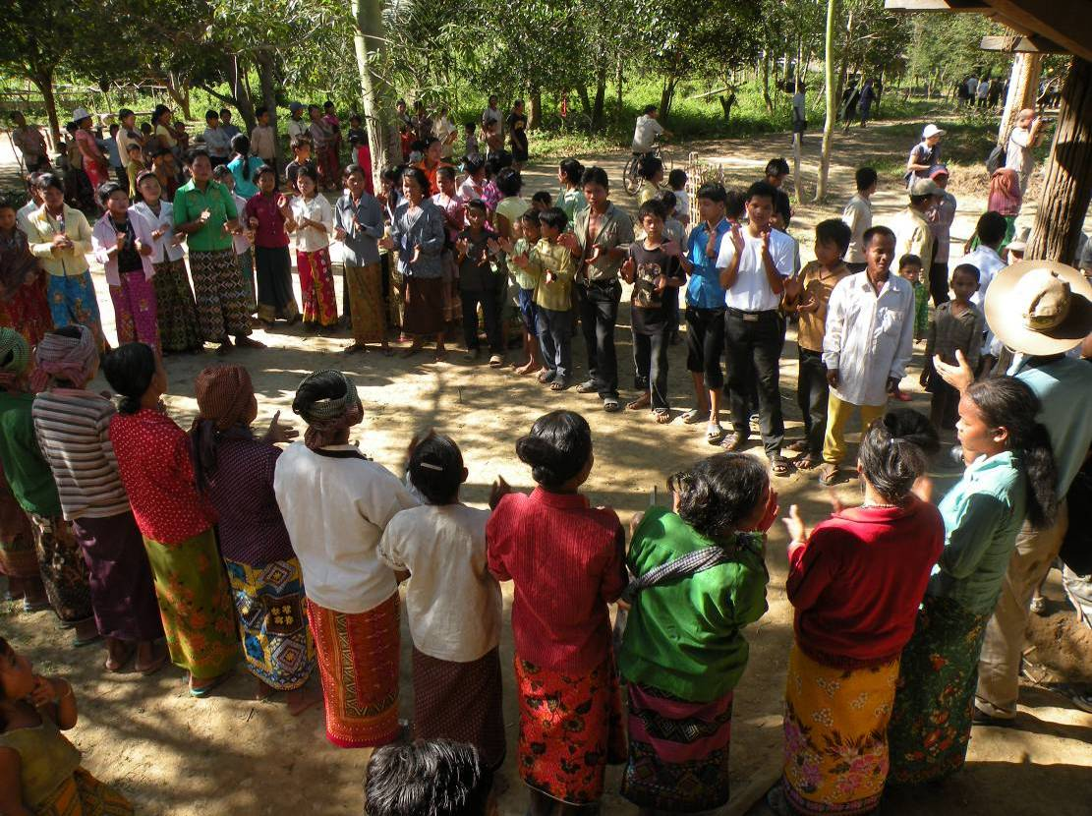

Grazia Borrini-Feyerabend and Jeremy Ironside

Report for IUCN/CEESP
February 9, 2010

Executive summary

This paper is concerned with the bio-cultural patrimonies of Cambodia that still are, or would benefit being, under the governance and care of the indigenous peoples and local communities customarily associated with them. Such patrimonies – internationally referred to as “Indigenous Territories and Areas conserved by Indigenous Peoples and Local Communities”, in short, ICCAs – are recognised by the Convention on Biological Diversity, which recommends their support. National recognition to respond to the CBD and other UN obligations has to follow suit, but it is often hampered by difficulties related to policy and legislation, and problems related to implementation and practice. The situation in Cambodia is no exception, although the brief survey and analysis carried out in November 2009 and summarised in this paper points at some reasons for hope and clear paths for action.

Security of land and resource tenure combined with respect for customary institutions and well thought-out forms of support responding to the specificities of the context are the ground on which the effective engagement of local residents in conservation can and should be developed. In close consultation with Cambodian professionals, we have visited and analysed a number of ICCA cases in Cambodia and identified a few policy options that appear feasible and potentially effective for their official recognition and support. This paper describes the ICCA cases we visited, their unique situations and the wishes expressed by their concerned communities. We then introduce the mentioned options for the official recognition of ICCAs in Cambodia, which are either already fully available under current legislation and rules, or could be made available through relatively minor modifications.

The paper ends with specific recommendations to all the national agencies, NGOs and supporting organisations concerned with bio-cultural diversity in the country. It is envisaged that they join hands and set up as soon as possible a set of parallel “pilot initiatives” to implement different options for the formal recognition of ICCAs in Cambodia. These initiatives, which would be set out in an experimental mode, would provide concerned communities with a form of common tenure to their ICCAs, with an emphasis on learning from the experience. Ideally, the initiatives would be set out as part of a national learning network, with focal point persons based in all the pilot sites. The network would ensure the on-going monitoring, evaluation and participatory discussion of the process of “implementing the options” as well as of their results and impacts.

We strongly recommend the competent authorities and supporters to establish the mentioned pilot initiatives and national learning network as rapidly as possible, and to foresee as its main output well-grounded advice and policy recommendations for the Cambodian government. This would fully respond to the directives of the CBD Programme of Work on Protected Areas, CBD COP 9 Resolutions and obligations under the UN Declaration on the Rights of Indigenous Peoples, of which Cambodia is a signatory country. By so doing Cambodia would also help secure its bio-cultural jewels— indeed an action whose time has come!

Background
In the first decade of the third millennium, international recommendations, resolutions and binding international agreements have brought to the fore the opportunity and commitment of the large majority of world’s countries to identify, recognise and provide appropriate support to community-initiatives in support to bio-cultural conservation. These include:
- World Parks Congress Recommendations (Durban, 2003) – in particular regarding the active engagement of indigenous peoples and local communities in the governance of protected areas;
- CBD Programme of Work on Protected Areas (PoWPA) (COP 7 Kuala Lumpur, February 2004) – in particular activity 2.1.3 regarding the establishment of policies and institutional mechanisms that facilitate the legal recognition and effective management of indigenous and local community conserved areas;
- UN Declaration on the Rights of Indigenous Peoples (Sept 2007) – in particular Article 29 that states “Indigenous peoples have the rights to conserve their environment and the productive capacity of their land and natural resources. State governments should establish and implement support programs to indigenous peoples to secure this conservation, without discrimination”;
- CBD decisions at COP 9 Bonn May 2008– in particular Decision IX/18 regarding the PoWPA Review, which asks CBD parties to give special attention to “improving, diversifying and strengthening various governance types for protected areas, and to recognizing them through acknowledgement in national legislation or other effective means”;
- IUCN Resolutions at World Conservation Congresses (Bangkok, 2004; Barcelona 2008) – in particular Resolutions 3.049 and 4.049, stressing that governance of protected areas by indigenous peoples and local communities should be promoted, supported and protected against external threats.
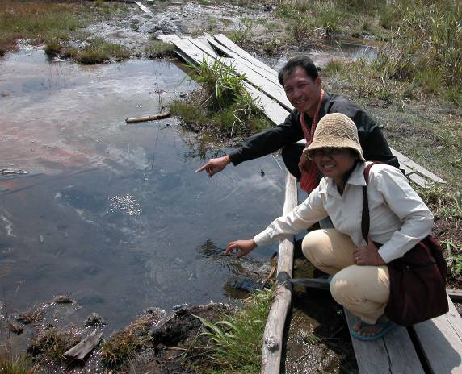
Throughout the world, major socio-ecological changes are affecting the relationship between local communities and their natural resources at an unprecedented pace. Natural resources are being alienated from indigenous peoples and local communities' customary tenure to large state enterprises and concessions held by timber, mining, oil, gas, biofuel, industrial fisheries and food farming companies—a process accompanied by rapid degradation of cultural and biological diversity. As part of the process, traditional farmers, herders and fishermen lose economically and culturally while the wealth of the country is transferred to elites and powerful companies, often of foreign origin.
Photo 1: Phnom Aural area (south-centre of the country): pointing at a local sacred spring under threat from mining and tourism developments.

Cambodia is no exception to the international commitments (the country signed both the Convention on Biological Diversity and the UN Declaration on the Rights of the Indigenous Peoples), and to the worrying process of change just described. While it was, until recently, the country in the Mekong Region with the largest proportion of forested territory, it is also the one that experienced the most dramatic pace of deforestation, mostly due to poorly controlled logging operations. In the 1990s deforestation took place both in government controlled areas and in the regions controlled by the Khmer Rouge opposition forces. In the government controlled areas vast concessions were granted to several large logging companies and “illegal” logging was commonplace. In areas controlled by the Khmer Rouge, timber resources earned them the funds to procure weapons. After the end of the insurgency in 1998, commercial interests have come to the fore. Logging concessions continue to be granted and large areas of often forested land are increasingly being given over by the central government as concessions to agricultural plantation interests. As a result, while in 1965 the country forest cover was estimated at 73 % of its total land area, this value decreased to 61% in 2002. In 2006, government estimates take the national forest cover to 59%. Besides overpowering commercial interests, insecure land tenure leading to rapid privatisation is also fuelling agricultural expansion and deforestation.

Despite all this, Cambodia still possesses important forest and freshwater resources, including in the Cardamom Mountains in the southwest, a large area of lowland evergreen forest in the centre-north of the country known as Prey Lang (200,000ha), and in the provinces of Stung Treng, Preah Vihear, Kratie, Ratanakiri and Mondolkiri in the north and north east. These are all areas populated by indigenous minorities.

Conservation by indigenous peoples and local communities
Indigenous & Community Conserved Areas (ICCAs) are“natural and modified ecosystems including significant biodiversity, ecological services and cultural values voluntarily conserved by indigenous and local communities through customary laws or other effective means”. ICCAs are identified by three essential characteristics:
- specific indigenous peoples or local communities (sedentary or mobile) are closely concerned with a bio-cultural patrimony (a territory or a body of natural resources) powerfully related to them because of traditional, spiritual and/or livelihood ties;
- such indigenous peoples or local communities have (de facto or de jure) taken and implemented management decisions about their bio-cultural patrimonies;
- their voluntary management decisions and efforts have achieved positive conservation results (although their intentions may not have been related to conservation).

ICCAs are the oldest form of conservation and exist today all over the world – in the North as well as in the South. They include:
- sacred forests, hills, lakes, springs and other natural features, including the habitats of sacred species;
- indigenous territories and cultural landscapes/seascapes;
- territories & migration routes of nomadic herders / mobile indigenous peoples;
- sustainably-managed wetlands, fishing grounds and water bodies;
- sustainably-managed resource reserves (e.g. biomass, medicinal plants, timber and non-timber forest products, water); and
- areas and natural resources purposefully set aside to support communities in time of severe stress (long-term community insurance scheme).

Throughout the world, ICCAs conserve a wide range of ecosystems, habitats and species, including particularly sensitive ecological settings and valuable functions, and contribute to the livelihoods and cultural identity for millions of people. Built on sophisticated ecological knowledge systems that have stood the test of time, ICCAs are managed through institutions “tailored to the context”, usually skilled at adaptive management and capable of flexible responses to intervening change. Despite their achievements, however, many ICCAs, especially in the South of the world, lack the official recognition of their governments and are in jeopardy because of a variety of intervening socio-economic and cultural changes.

ICCAs in Cambodia
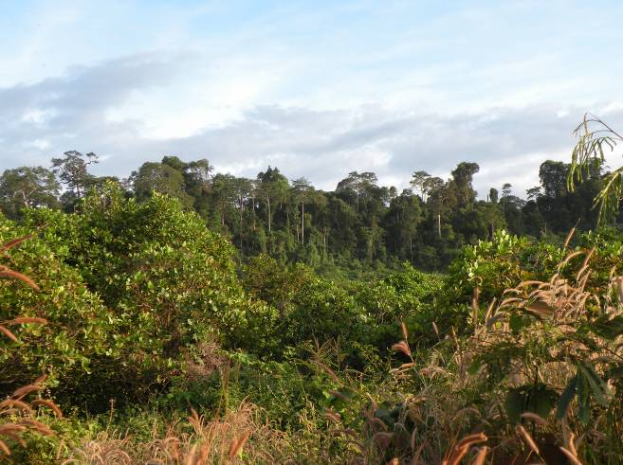
Cambodia – a country endowed with rich biological and cultural diversity— is blessed with a variety of ICCAs, in particular sacred hills, lakes, forests and other unique natural features (e.g., caves, waterfalls, rocks). These “bio-cultural jewels” harbour unique biological diversity and are usually connected to one or more communities, many of which relate to them strongly, in culturally-rich and spiritually-powerful ways. In upland areas a typical pattern sees a community of rotational (shifting) agriculturalists closely associated to the head hill of the brook or river along which the rotational agriculture is practiced. That head hill is usually home to a patron “spirit” (Arak Neak Ta, in Khmer) commanding respect and capable of producing a variety of nefarious consequences when angered.

The belief in the existence of earth spirits or “spirits of the land and water” is common to all people of Cambodia, whether they are from towns or countryside villages. Everywhere, the presence of such spirits is marked by a mixture of respect and familiarity. Spirits can have different degrees of power and direct relationships with humans but have a general tutelary role, they “watch over” and “protect” the land and people and ensure prosperity and good health as long as customary rules are respected. Characteristically, they reside in a feature of the land – a hill, a lake, a cave or even a rock – and can heal, but also punish and torment people. In lowland parts of the country, they represent a spiritual hierarchy superimposed to all human hierarchies, coexisting in a syncretic mixture with Buddhist beliefs. In upland areas, generally inhabited by indigenous peoples, they are part of a dominant animist tradition which recognises lesser and more powerful spirits living throughout the landscape.
Photo 2: Ndroo sacred Hill, La-en village, Ratanakiri Province.

The spirits embody the energy force linking the people to the fertility of their land and their ancestors before them. The presence of a spirit in a given area, let us say a hill, does not impede people from utilising natural resources found there, but disrespectful behaviours – such as indiscriminate timber felling, pollution, killing of certain animals and destructive mining – is clearly forbidden. Even the very presence of people from outside the area can be interpreted by the spirit as offending behaviour, to be placated by offering a sacrifice (this could be a chicken or even a pig or alcohol in the form of a locally made rice beer). These beliefs create a powerful stewardship relation between a given community and one or more given areas of residence of its patron spirits. The residents in the community feel a mixture of rights and responsibilities with regard to the sacred area at stake. On the one hand, they believe they have the right to collect forest products, for instance, or to use the water that comes from the sacred hill. On the other, they feel the responsibility to preserve its integrity and make sure that a respectful behaviour is maintained not to anger its tutelary spirits.

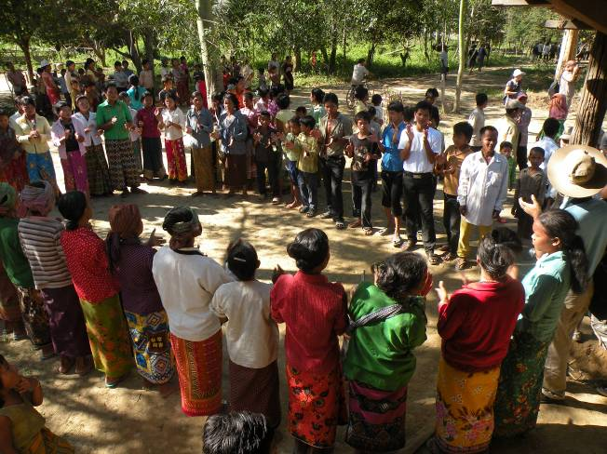
A variety of major events and factors have been interplaying with and shaping the relationships between the Cambodian people and the nature spirits– from civil war and the murders of the Khmer Rouge regime, to widespread corruption and anarchic natural resource management, from “development” projects and conservation initiatives (such as the establishment of 23 protected areas in the country) fuelled by foreign aid, to the presence of international investors combing the country for oil, minerals and arable lands. Despite all these events and factors, there is little doubt that ICCAs still exist and remain a respected phenomenon in Cambodian society. This is particularly true for Cambodia's indigenous people, but Khmer people, especially in the countryside, also know about the existence of the spirits of the land and water and hold them in respect.
Photo 3: Kavet people in Kok Lak Commune, Ratanakiri Province.
In November 2009 a rapid spot-survey of ICCAs was carried out by the authors of this report in the Cambodian provinces of Ratanakiri, Siem Reap and Kampong Thom. A few “caretaker communities” were encountered and field visits and interviews with government officials and others were held to discuss the current status, problems and needs of their ICCAs. These visits and findings are briefly described below. From these, a few recommendations are drawn addressing all the national agencies, NGOs and supporting organisations concerned with bio-cultural diversity in Cambodia.

Spirit hills of Kavet communities in Kok Lak Commune, Ratanakiri Province.
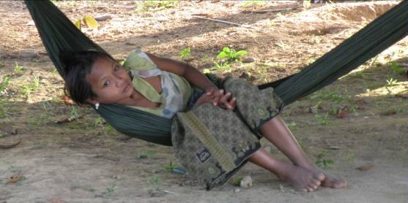
The villages of La Meuay, Ndrak, Lalay and Rok (about 462 households, 2000 people) are inhabited by Kavet communities that used to live inside what is now Virachey National Park, in Ratanakiri province, close to the Lao/Cambodian border. Following earlier attempts at sedentarising these people in the 1960s, the government managed to “convince” them to move out of the park in the 1980s and 90s. This was partly due to the presence of Khmer Rouge soldiers in the area, but also to the fact that the government wanted to move people closer to services and out of the national park. The villages are currently established in lowland areas south of Virachey NP, along the lower banks of the Lalay river.

When they lived in the mountainous areas inside Virachey, the livelihood of the Kavet people was based on shifting agriculture (SA) practiced in the bamboo groves along the sides of rivers and streams. This is a knowledge-dense practice where several plots are used in succession by a family through cycles of cultivation and fallow. Serious scholars recognise that fallow areas under shifting cultivation regimes are rich in biodiversity and the actual fields under production are rich in agro-biodiversity. Conventional conservationists and agriculture experts, however, have generally condemned the practice. It can be argued that it is because of this lack of understanding, which has been and continues to be quite widespread, that the Kavet peoples have been expelled from Virachey, where they had practiced shifting agriculture for centuries.
Photo 4: Kavet girl in Kok Lak Commune, Ratanakiri Province

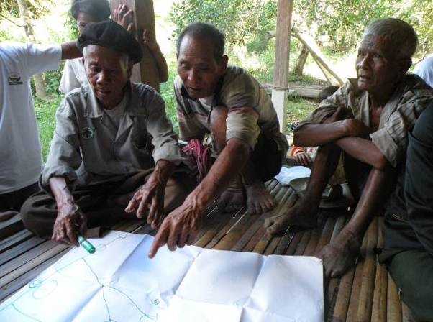
The basic pattern of shifting agriculture among the Kavet people is a closed cycle: a succession of plots is cultivated progressively on one side of a stream for a number of years and then backwards down the same stream, on the opposite river bank, for approximately the same number of years. Villages are also regularly built and abandoned when the swidden plots get too far away from them. The plots yield mixed harvests of dry rice, corn, pumpkins and gourds, beans, vegetables, bananas, papayas, root crops, herbs and spices. In the case of the Kavet people, shifting agriculture in the vicinity of rivers is combined with strict conservation in the hills, where the spirits live, forests are abundant with useful products, and one can also find sacred springs and lakes (“life springs”), etc. People go to the forest in the hills to collect a variety of products – from vines to mushrooms to forest vegetables to medicinal plants to fruits. Traditionally the Kavet have lived without need to fell large trees for timber. Burning hill forests for shifting agriculture has not been practiced, partly because of the relative infertility of rocky hilly terrain. The Kavet and the closely related Brao people are known as “bamboo people”. They use bamboo for all their building material and for most utensils. And bamboo grows close to water, where they traditionally cut their swidden fields.
Photo 5: Elders of Lalay Village discuss their spirit forest areas and their worries about the mining explorations that have recently taken place there.

The four villages we visited have jointly been assigned an area of approximately 10,000 ha as “community protected area” (CPA) inside Virachey NP (known locally as the O Tung CPA). This kind of denomination identifies a zone within a national protected area for which a community is “recognised” as having some pre-existing customary rights. CPAs are to be governed by a community committee but, to date, park authorities retain control of O Tung CPA. The villagers can collect forest products there, but they are neither allowed to cut trees nor do their shifting agriculture there. Importantly, they do not feel they have control of the situation.

Recently, the situation became complicated by the fact that the government allowed mining explorations to take place inside and outside Virachey National Park, and in particular close to the sacred hills where the spirits live. As we interviewed them during our visit, Kavet people told us that the unprecedented floods that happened at the end of September 2009 are surely the direct consequence of the mining disturbances. Mining irritated the spirits who live in the hills just above the excavations. Incidentally, the allocation of mining exploration licenses inside Virachey NP may have been an important factor also in the decision of the World Bank to abandon a proposed extension of their management support to the park.

The Kavet communities appear to have relatively little knowledge of their legal rights, despite being assisted by a local NGO. What they know is that they need more land, be it within or outside the park, and in particular land suitable for shifting agriculture (each family needs 5-7 ha). They are, it is true, engaged in some land use planning exercises to delineate and request areas for shifting cultivation inside the CPA, but support for that has not been consistent. Until there is an agreed management plan for the CPA, the situation will remain unclear. Earlier attempts by Kavet communities to secure Community Forestry areas outside of the park with the support of the NGO Non Timber Forest Products (NTFP) also never managed to achieve positive results. And those attempts are even less prominent since a main community leader, involved in this work since the beginning, died from a snake bite. There are now competing claims over the forest areas of Kok Lak Commune outside Virachey NP. A logging concession was awarded over this area in the early 2000s, but it has remained inactive until now. Communities continue to request for parts of the land as community forests, and there is now a new proposal, advanced with the help of foreign conservation organisations, to establish in the general area a new 55,000ha protected forest.

Important spirits of the Kavet communities reside outside the park, within the park and in the CPA. The areas have special characteristics (different size bamboos, rocks, caves, waterfalls, grasslands, vistas, beauty) and people go there for ceremonies (this is difficult when spirits reside in the core of the NP) and need to observe special rules and rituals there (e.g. only Kavet language can be spoken, and at low voice). Going to these places means potentially being exposed to a variety of dangers and diseases. Village elders stress that respecting these places is very closely connected with the fate and livelihoods of the Kavet people.

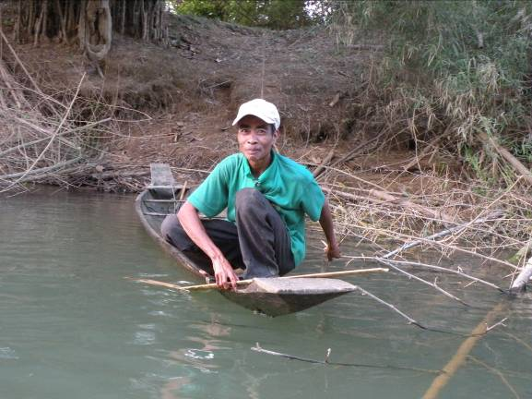
The indigenous communities are still passionate defenders of forests, especially the headhills of their streams and other sensitive ecological areas. It is not yet clear, however, how their culture and beliefs will evolve now that they are living on land where shifting agriculture cannot be practiced to the extent needed to sustain them, as they do not have enough suitable land. They attempt to combine SA and sedentary paddy rice cultivation, but the recent flooding has destroyed the paddies and many are resorting to eating yams and tubers from the forest. This and the presence of other resources which are vital for livelihoods is why these communities want access and use rights to forest areas inside and outside of Virachey National Park. While a CPA management plan is yet to be completed (for inside the park), it is not yet clear how the management of areas outside the park will eventually be allocated. In the absence of a basis for their livelihood, it is no surprise that some Kavet may resort to re-enter the protected areas to illegally extract timber and hunt wildlife for sale — something they never did before.
Photo 6: The Lalay river, which flows down from the mountains separating Laos from Cambodia, is the life blood of the Kavet peoples of Kok Lak Commune

As we see it, the indigenous territories of Kavet people within Virachey NP were excellent examples of ICCAs. But the Kavet have been forced out and have lost their control. The areas just outside Virachey NP where they still worship hill spirits and practice shifting agriculture along the river banks – together with the O Tung CPA where they are now allowed to collect some minor resources and might in the future be allowed to carry out shifting agriculture – can still be examples of ICCAs. There are open questions, however, related to livelihoods and governance.

Unless the communities can find their livelihood on the land where they have been brought to live, they will be compelled to find other solutions—legal or illegal. Paradoxically, forbidding shifting agriculture within the CPA could be a main factor in the promotion of illegal behaviour. What is needed is to make sure that each community can have secure access to enough land of the appropriate types to develop a sound and varied livelihood strategy (enough bamboo areas for shifting cultivation, enough forest for wild products, enough land for paddy rice cultivation, hill areas protected for the village's spirits, etc.).

Moreover, ICCA-community relationships need a close match between natural and social well-defined units. In the past, villages took responsibility for their territories, which came to them from history and the direct experience of their fathers and grandfathers. The CPA promoted by Virachey NP is an area defined by park managers and governed by a committee where (supposedly) at least four communities are represented and have to agree with Park managers and guards. This possibly includes an un-necessary layer of complications and separation between the people and their natural resources. On the one hand, the committee should be able to play its role, which is not truly the case (it has not even the resources to meet). On the other, the four communities have complex roots in different ancestral areas inside the park. Although they all recognise O Tung CPA as traditional land of the Kok Lak people, it is to be clarified whether they truly feel as possessing a common “social identity”.

Sacred lake of Yeak Laom, Yeak Laom Commune, Ratanakiri Province.
A volcanic crater lake in Yeak Laom Commune has been sacred to the local Tampuen people for many generations. Situated right next to the provincial capital, it has remarkably remained basically free from timber exploitations (its banks are heavily forested) and major constructions. An exception came to be in the 1960s, when a King’s palace was constructed on the shores of the lake. This was destroyed during the years of war, to be followed in the early 1990s by a lurid story of prostitution and a karaoke bar set up right on the lake shore. A new King's palace was then constructed in the mid 1990's but, when finished, there were no funds to pay for it. The Provincial Governor thus asked a Canadian aid agency if they would rent the building to establish there a centre devoted to culture and the environment.
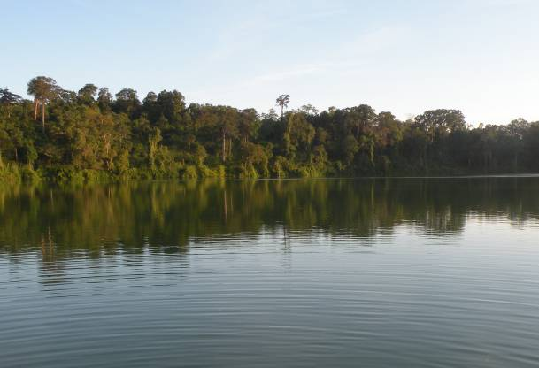
In this way, taking advantage of the presence of a progressive governor and of the technical and financial support of IDRC, in the late 1990s, the Yeak Laom community managed to have the lake rescued from the prostitution and karaoke story. In fact, it obtained its declaration as a “provincial protected area”. IDRC and a follow up UNDP project facilitated this achievement as well as the setting up of a local committee to manage the lake and the cultural/environmental centre, rebuilt in place of the destroyed King’s palace.
Photo 7: Yeak Laom crater lake, around 800m in diameter

The provincial protected area is under the management of its caretaker community through a 25 year lease contract. This limited and rather fragile tenure is less than ideal, but it manages (for the moment) to stop outside tourism companies to appropriate the area. For now, the lake is just open to day visitors. The local community takes care of management and cleanliness and collects the lake entry fee, from both national and international tourists. To date, income from the lake has only covered the costs of maintenance and improvement of the tourism infrastructure.

The situation has considerably changed since the old days. In the distant past the lake was never disturbed and people feared even to go there as they were afraid of the spirits inhabiting it and the surrounding forests. Only a few people went there for fishing, and when they did so they behaved very respectfully and refrained even from making noise. Now there are plenty of swimmers, handicraft shops, etc. But the lake is still a natural area, no concrete buildings are allowed to be built, no people are allowed to stay overnight, the crater is still well forested and the governance power is still in local hands. We can thus say that Yeak Laom lake is still an ICCA. Its history has been alternate and its future is uncertain, but for— the time being— the Yeak Laom community managed to greatly benefit from technical support to negotiate its role as manager of the provincial protected area. The community is still in control and, for the moment, conservation is ensured.

In the brief meeting we had with the lake management committee we heard about the above, and about the fact that the company wanting to build a cable car and hotels (3 and 5 star) on a nearby hill recently distributed some bags of rice and soy sauce to the community members. In a meeting community members were informed that Youl hill (see below) had been given by the government to a company to develop and -- somehow related to this -- all families in the Commune were given 20kgs of rice and a carton of soy sauce. Villagers were told that this was a gift, as is often given by the powerful to villagers in Cambodia. But people were then asked to thumbprint a document stating that they had received these gifts, and some of the local authorities questioned why it was necessary to thumbprint a document for receiving gifts. They had not heard of this before and refused to submit the thumb-printed documents from their villages. It is not yet clear whether the gift is “related” to some concession the Community would be asked to make.

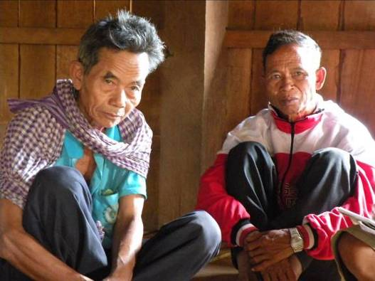
When we talked with other people in Phnom village in Yeak Laom Commune we heard that they are against allowing the company to appropriate the hill, but they are afraid to protest. They told us of a separate incident where someone who protested against a land deal was shot at! What is sure is that the company that came up with the gift has since completed a road around the sacred hill (see below).

Sacred hill of Youl, Aikapiep and Yeak Laom Communes, Ratanakiri Province
Phnom Youl is the most important sacred hill and spirit forest of the Pachon community (Ncharr in Tampuen language) of Aikapiep Commune. Community elders and authorities stressed to us that that they have protected the hill for a long time and as late as 2007 they stopped some externally-originated logging activities there. The forested hill is accessed by the local communities and even by outsiders to collect bamboo and other non timber forest products. In principle, the community is not opposed to tourism development, but it wishes, first of all, that the hill is respected and their rights to it as caretakers are recognised.
Photo 8: Pachon village elders discuss their management of Youl hill
We discussed the hill at some length due to the mentioned recent road construction all around it. This work was done by a private company to delineate the area they have been granted by the government as an 'eco-tourism' site. Local villagers have heard the rumours that a casino/hotel and cable car will be built on the other side of the hill near to Yeak Laom lake, the sacred lake of the community on the other side of the hill. No one came and consulted with the Pachon community before bulldozing this road. And, as the hill is under a different commune’s administration, not even the Commune Chief was consulted. The villagers are afraid that the desecration of the hill will bring them bad luck and disasters. When they managed to get hold of documents handing over this hill to the company and allowing the company to cut the road, they saw that these developments have been signed off by the Minister of Agriculture and the Governor of Ratanakiri.

The villagers wonder whether people on the other side of the hill in Yeak Laom Commune (who claim some rights, as some of them in the 1960s, “bought” land and established a village in the area of the hill) did enter into some deal… As noted above, we were later informed that Yeak Laom did not make any deal with the company, but their residents received some bags of rice and cartons of soy sauce, which made them wonder…
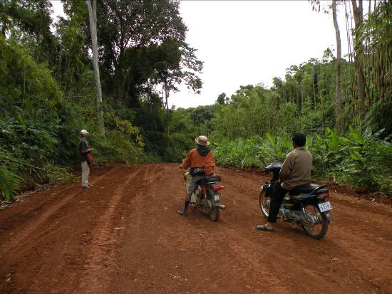
Villagers are worried about rumours that the company may build a fence along the bulldozed road and block their access to the resources in the area. Some villagers on the Yeak Laom side of the hill who have farms in the area were given the 'choice' of accepting compensation for leaving their farms or staying on condition they do not increase their farm area. Some have decided to stay, as they don't have other land. They have been told by the company that they will become its employees and that the company intends to build a 'cultural village' for the hotels/casino guests to visit.
Photo 9: The new road bulldozed around Youl hill by the “eco-tourism” concession company

People from both sides of Phnom Youl have peacefully extracted forest resources from the hill forest for a very long time, without any problem among them. But problems may now emerge. All the residents of the three villages on the Pachon side of the hill, who believe they are the rightful caretakers of the sacred home of the spirits, signed a letter of protest to the Ratanakiri Member of Parliament. The MP admitted that the hill is Pachon land and they should have been involved in discussion about this deal. But this was in May 2009, and nothing has happened since. The Member of Parliament met with village representatives and informed them that he can not do much. He said he could support from behind but it was up to the villagers to raise their voices on this issue. During our meeting we saw the letter and its impressive long list of 1,000 thumbprints as signatures, but we also found out that it is mildly worded and has no legal value. In particular, the Pachon people insist in discussing a proposed boundary with the Yeak Laom Commune, which cuts across their hill rather the attacking the essence of the problem, which is the act of the company that went ahead without the formal permission of the traditional landowners.

In this case we notice a rather common occurrence, namely that an ICCA is body of resources (a hill and forest) for whom two communities believe to be rightfully associated. For one of them at least we can say that powerful cultural and caretaking/ managing ties existed for a long time and justify customary rights to be recognised today. Powerful modern actors, however, seem to have managed to pit one such community against another, coming out as the real winners. The losers so far, of course, are the local ICCA and people. Inter-community solidarity, which has not yet managed to get established in this case, might help both communities to obtain better results.

Sacred hill of Yetnang, Teun Commune, Ratanakiri Province.
This is a prominent hill west of Ban Lung town, the capital of Ratanakiri Province. In fact, Yetnang is the most powerful of all spirit areas in the whole of Teun Commune. Several hills dominate the landscape here, and are believed to be inhabited by spirits with the power to either assist or cause harm to peoples’ lives. These hills include Yamoc, Bralair, Kachang, Lao, Tung, Kasie, Tourr, Satuk, Brala, Tropang, Jong, Deine, Ngeul and Yetnang, which is the most important. The Kreung and Tampuen people in 6 villages of Teun Commune recognise and call the spirits of these hills when they hold their ceremonies.

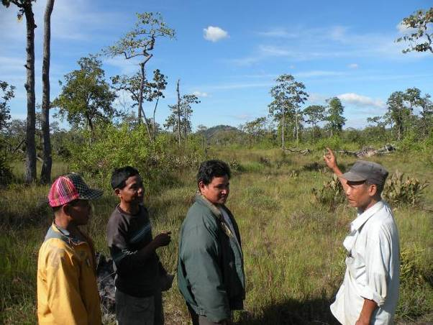
We travelled together with some elders and local residents to a clearing in a dry forest within sight of the hill of Yetnang (about one kilometer away). The car driver did not wish to go further, citing the bad conditions of the road. The local people who accompanied us seemed to agree (going further would have likely required the sacrifice of a pig to the hill). There are a number of legends regarding the hill. In one of them, the hill is feared because it has a reputation of “eating people”. In the past, another hill (Klar Bo) came to visit, was served food and, after eating, saw that the pot contained the hands and feet of people. Yetnang refused to admit that this was true. Klar Bo discussed the incident with other nearby hills and they all thought that the best way to resolve the dispute was a test (sabot, in Khmer language), which is a traditional practice in this area. Thus, Klar Bo and Yetnang both submerged themselves in water. Yetnang came up from the water first and therefore lost the trial, confirming that indeed Yetnang had served and eaten people. We were told that the hill is gifted with special rocks, large caves (in the past the home of tigers), springs and very clear water at its feet. There are three layers of caves in the hill, with the most powerful of a hierarchy of spirits inhabiting the highest one. This is a mischievous place, and people have been known to get lost when they walk in the forests in the vicinity of this hill.
Photo 10: Teun village elder and residents point out Yetnang hill in the distance

While Yetnang's special top place in the local hierarchy of sacred hills remains unchallenged, it is now under a new and serious threat. People say that the hill is rich in marble, and there is also talk of the presence of iron ore, diamonds and other gems. Apparently there is a strong possibility that the whole hill will be dug up. A foreign company (Vietnamese) has held a concession to exploit these minerals for a few years now. Only villagers’ refusal to allow mining has stopped them up to now. Local people say if mining is allowed to happen in the hill, people will get sick and die. Villagers reported that an assistant District Chief recently had a stroke, and a senior member of the Vietnamese mining company also died! The company started preparing a road from the District town three years ago to allow access to this hill, but they soon stopped. About a year ago, a hundred workers arrived to start work on the road again, but it rained, and rained… It stopped raining only when the workers took their tents away! Villagers also recounted how a truck that took a piece of stone from the hill for testing overturned on its way back to town...

In another incident the traditional leader of Teun Village, the Teun Commune Chief and the MP for Ratanakiri (who is also indigenous Tampuen) went to Kon Mom District town with the intention of asking the Yetnang spirit if it would allow mining of the hill. Only the traditional leader and the Commune Chief went to the hill as the MP stayed in Kon Mom, deciding it was best to keep at a safe distance. The two Teun leaders performed a ceremony offering to the spirit four chickens and some rice wine, and asking for the permission to mine. That night the traditional leader dreamed he saw the spirit personified as an old man with a beard, who was very angry. The leader said the spirit in the dream would not bear the mining of this hill. After this they had to ask the MP for a pig to sacrifice to calm the spirit’s anger. The traditional leader said it rained heavily and only after they offered the pig to the spirit did it stop raining.

The village and commune chiefs have been calling meetings to discuss this issue and the people do not wish this mining to go ahead at all. They may be weary to say no to their superiors, but they all agree that mining should not take place, because they are afraid of: 1. sickness and death; 2. getting struck by lightening; 3. drought; 4. floods; 5. storms and cyclones. According to local customs, the feared and powerful Yetnang spirit demands revenge, if irritated, and needs to be placated. Despite all this, we are told that the Vietnamese company expects to start activities in February 2010.

A year ago an NGO came to get information on the sacred hill and even made a CD about it. They tried to help the local communities in their struggle against the mining company, but they could not do much, really. The MP for the area has been adamant that work should proceed (“If you will let us, we’ll do it. If you do not let us, we’ll do it the same!”). The communities say they need technical support, support to develop a legal complaint, other ideas about how to stop the company, and even money, as they know that opposing individuals can be arrested and it is a difficult process and funds are required to get them out of jail…

The Sacred hill of Yetnang is an example of an ICCA culturally connected to several communities by a tie of profound fear and respect. It may or may not survive the current modernization expansion (there is a fully fledged factory for road construction in the district town closest to the hill which could be used for building a road to the hill) but the people with customary ties to it have the right to have a say in such developments. Besides that, they should be supported in their decision by a clear understanding of the impacts that mining of the hill may have on their livelihoods – ultimately, as they are well convinced— on their lives. As we spoke with the members of the concerned villages, it seemed to us that they were in a state of deep ignorance regarding the possible economic value of the hill’s resources the claims for exploitation and the possible related impacts and/or benefits. Relevant information and technical analyses including impact studies would be extremely helpful, we believe, to help them make meaningful decisions.

Ndroo Hill, La'en Village, Teun Commune, Ratanakiri Province
This village is one of the three in the country so far chosen for pilot communal land titling for indigenous communities under the Ministry of Land Management, Urban Planning and Construction, and Cadastre (MLMUPCC). Land use maps for La'en Village were developed in the early 2000s with the help of a Khmer NGO. Of the 7250 ha of village land, the government’s Forest Administration considers about 4000 ha as forest land under their jurisdiction. By law, such forest land can be classified as production forests and allocated as “concessions”, as “community forests” (albeit of limited area) or as “protected forest”. Following the 2002 Forest Law, local communities can continue their traditional collection activities of non-timber forest products in the “forest land” of their village.

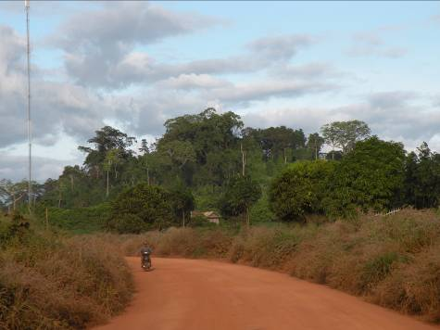
Of the remaining 3000 or so ha of land in La'en Village, only about 700 ha is community land eligible for a communal land title. Further, out of this 700 ha only 7 ha can be titled as a “burial forest”, and only 7 ha as a “spirit forest”. This is the maximum that can be reserved for these designations under the law, following the guidelines established for communal titling of indigenous lands. This is to be strictly implemented, even if it is not sufficient to protect all the areas that the village consider as sacred. As a matter of fact, La'en villagers have had to choose between two main sacred sites they want to secure under communal title. One is Ndroo hill and the other is a sacred grassland area called Singearr within a forested area. A local village champion who received training in administration during the 1980s tried to argue that Singearr was a “forbidden forest area” while Ndroo was the village's proper spirit forest area. Government officials replied that those were exactly the “same thing” and they could include both areas within the communal title only as long as their total size does not exceed 7ha. Because of this restriction the village ended up considering it better to allow some families to use part of the sacred grassland area while reserving 7ha of it as a “spirit area”. In this way the area is now “titled” for community use and no longer a forest area, of which the village would have lost management control.
Photo 10: Photo 11: Ndroo hill from the main road through Ratanakiri Province

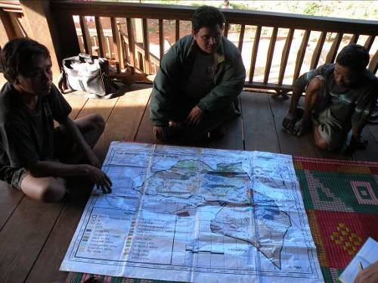
Having exhausted their 7 ha, the community could not hope to get a title over Ndroo hill as a spirit area. It then decided to allow the outside Khmer cash cropping farmers from La'en and neighbouring villages to build a pagoda on top of the hill. They argued that in this way the area will remain a public space and not under any restrictions or unwanted use, which might be imposed by the Forest Administration. Villagers say they have been consulted by the people planning to build the pagoda about whether this would interfere with their beliefs. They say the Khmer people will take the Tampuen name of this hill as the name of the pagoda. The villagers also say that there is a large area of more than 10ha on top of this hill, so one part of it can be used as a pagoda while the rest will stay protected as a spirit forest area. In other words, the community had to find some convoluted compromises, and lost part of its sacred land, but managed to maintain common possession of as much as possible of it.
Photo 12: La'en villagers present their land use map and discuss communal land titling activities in the village.

As seen above with only 700ha remaining out of a possible 3,000ha, there has been a frenzy of privatisation, with most of the good upland soils now in the hands of outside private interests. Land buying by outsiders has progressively reduced the amount of land that the Tampuen inhabitants of this village have available for upland farming and for registering as a communal title. The buyers are Khmer people from nearby lowland villages or even from afar, and prominent among them are government officials. Land is bought for cash cropping and is increasingly being planted with rubber. As mentioned, the village's communal land can be used for productive ends by individual families. It can be lent and borrowed within the village. However the major wave of recent privatisations worries everyone. That is why the Tampuen people want as much as possible of their land under a communal title, to prevent further land selling for the sake of a future for their children… The local “champion” mentioned above has been prominent in assisting his village through the process of obtaining a collective title. Although he is still providing assistance, he has recently decided to let others take over some of this work and declined to be on the village representative committee that will legally hold the village's communal land title.

Prey Thom (big forest) and CPAs within Phnom Kulen National Park, Siem Reap Province.
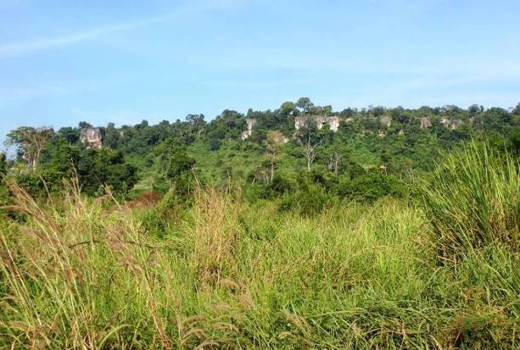
Phnom Kulen National Park, north of Siem Reap town and Angkor Wat, was created in 1993, when the Ministry of Environment developed the national protected area system. For several years, however, access to the National Park was simply not possible. The steep hills and forested terrain made it a Khmer Rouge (KR) stronghold, where they could set up camp after their power faded and their crimes had been exposed. Political reconciliation finally took place in 1997-98, opening access to the region, and Phnom Kulen National Park within it.
Photo 12: Limestone cliffs are the gateway to Phnom Kulen National Park, Siem Reap Province
No surprise, many ex-KR still live within the park. Some have been integrated in the country’s military units and others live in a village that developed in the last decade in the middle of the Park’s forest. Kulen Park authorities consider that the residents of this village are illegal settlers, but during our visit we noticed recent infrastructure development, including a large new school. It seemed to us that those are signs of an inevitable long term establishment of the village. Some of these ex-soldiers are allegedly engaged in illegal logging. Because of the legacy of KR occupation and the lenient reconciliation process they are still considered as very powerful….

Besides the new illegal village, there are eight much older villages within the National Park. When the current zoning process will be completed, the area around these older villages will most likely be declared a “Community Zone” (i.e., an area within the park where people are allowed to have houses and even plots for their traditional shifting agriculture). In the meantime, they are left in peace to live where they always have, and they have negotiated privileged access to five Community Protected Areas (CPAs), with a total area of 1088 ha. These areas are under the direct management and protection of the residents of the eight villages, who can still collect there non-timber forest products according to their customary rules. Unlike the CPA of O Tung in Virachey NP ( Kok Lak Commune), the five CPAs relevant here are relatively small areas (ranging in size from 77 to 306 ha). They are, however, essential for the livelihoods of the local communities, as they are rich locations for harvesting lychees, the main forest product sold locally as a cash crop.

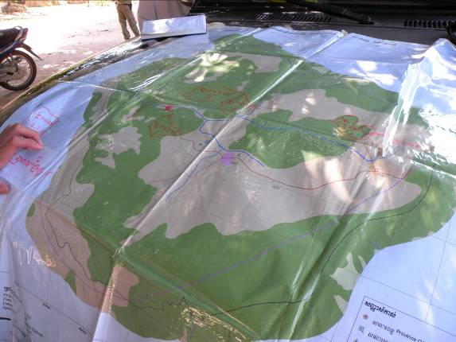
The development of CPA management committees for the five CPAs was facilitated by an FAO community forestry project that operated in the area a few years ago. The community CPA committee consists of seven members including two women, elected democratically by the general village assembly. The committee is thus composed only of community members, and it is fully in charge of management (demarcation, rules of harvesting lychees, patrolling, establishing firebreaks, etc). The committee calls for the support or advice of National Park rangers – who reside in their Headquarters within the park – only in case of need. Committee meetings are held once a month. The Chief of the commune says everyone appreciates the CPAs very much, as they helped to control the anarchic exploitation of the forest, which was common place before their establishment.
Photo 13: Reviewing a commune land use map with Phnom Kulen CPA committee members

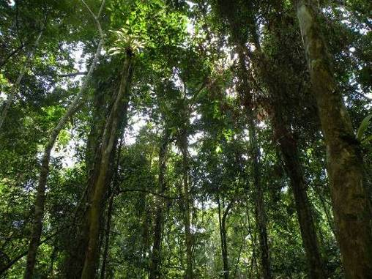
The most important resource extracted from the CPA are lychees, which are found in so many varieties and qualities to merit naming the forest and hills as the original birth place of the fruit. Lychee trees are collectively protected, but the fruits are harvested and sold by each family. The harvesting process is demanding and dangerous as it involves climbing very tall forest trees. Some pruning of the trees is carried out by cutting off branches, a treatment that stimulates the production of more fruit. Because of these tending practices, families end up associated with specific areas and trees. Families also sell the fruits individually, taking advantage of whatever means of transportation they find or relying on buyers who come from nearby urban areas (with the advent of portable phones, price and market information are well known even in remote villages and it is possible to protect one’s family against unscrupulous buyers).

The community members, however, are not only concerned about lychees and their demarcated CPAs. They actually deeply care also about other particular areas in the forest, where the spirits live. These areas – called Prey Thom, or “big forest” in Khmer at times include water sources or old temple sites. Prey Thom areas remain well protected to this day. Timber is not cut there for fear of the spirit's reprisal… but it is possible to collect rattan, vines, wild fruits and traditional medicines. The community is concerned that outsiders can come and try to extract timber from those areas, so they extend their patrol to the Prey Thom areas, even if they are far from their CPAs. Just two weeks before our arrival they had found out that people wanted to cut trees in one such area, and alerted the rangers and the head of the CPA Committee. The villagers watch out that this cutting will not take place. They actually very much appreciate being inside a protected area, as they can ask for the help of the rangers, in case of need. Also, they say that living in a forested area means the rains are abundant and regular, which is good for their farming.
Photo 14: The lychee forest and CPA, which villagers harvest for their fruits

Another advantage of the protected area is that all land selling and buying is illegal inside the park, the local authorities cannot approve or witness land sales. The local villagers rotate their shifting agriculture fields in areas that are customarily part of their village and there are no problems regarding internal land subdivision for the regular use of resources, which is well regulated by custom. Villagers say that if someone leaves the village, their land can be passed on to others within the village, but also taken back when people come back and reclaim it…
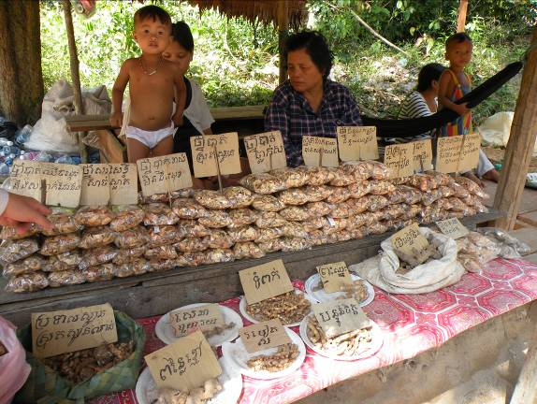
This situation which seems to please everyone may be short lived, however, as we understood that in the future individual community residents will be legally entitled to apply for a land title inside the designated Community Zone, which includes their agricultural and residential areas. At the moment the park zoning has not been completed, so it is not yet possible to obtain a title. The National Park’s authorities are rightly afraid that land titling will open the door to land speculation… and this is a good reason to proceeding cautiously with park zoning. It also seems to us that this is also a good reason to proceed with future collective rather than individual titling…
Photo 15: Local market displays of traditional medicines collected from the forests of Kulen National Park

In the past, decisions about natural resources were taken by the elders, who were very concerned about the protection of the forest and water. People had to be supportive of one another, as there were few residents in the villages and they had to face common difficulties together, including the dangers of wildlife, such as tigers. Now due to the long years of war and poaching, only birds, wild pigs and deer remain in the area. The sustainable extraction of lychees and the protection of the forest, however, is not a new idea at all. The elders know much about it and would still be able to maintain a sustainable use. But more and more people collect traditional medicine, fruit, and natural resources in general, including fish and the little wildlife that is left, for the market. This promotes collecting as much as possible, and the resources are suffering. Internal population increase and limited land area also mean that periods in rotational agriculture have declined from the ideal 15 years to 8-10 years. The CPA Committee discusses these problems, and some solutions have been attempted, such as planting improved varieties of lychees and medicinal plants around home gardens and agricultural areas… The traditional medicines that come from large trees, however, cannot be easily produced or propagated.

In our view, both the CPAs and the Prey Thom areas qualify as ICCAs for the eight old villages. We asked the Committee and Commune Chief whether they would like to have a special status for their Prey Thom areas and a clear responsibility for their conservation. They answered that a feasibility study should be carried out, and some management procedures developed. In particular they said that they would like to officially extend their voluntary patrols to the Prey Thom areas and, if they find illegal extractive activities there, they could coordinate with the rangers for their preventive and repressive action. They are not afraid about patrolling on their own, as their experience is that they do not need to get into fights with the people who do not respect the rules, they just need to talk to them. But they surely welcome the support of the authorities to repress illegal activities in their ICCAs.

ICCAs within Bung Per wildlife reserve, Kampong Thom Province
The wildlife reserve of Bung Ber has a tragic history of fighting and intense bombardment during the recent decades of war. Demining has just been done on the side of the main road that connects Kampong Thom and Preah Vihear provincial towns, crossing the reserve from South to North (it takes 2 to 3 hours to drive along a dirt road through the park). In the forest, cows and buffalos still occasionally tramp upon a mine and cause it to explode. Because of the strategic importance of this road and the proximity to main Khmer Rouge bases, it used to be a passage in the forest where the Khmer Rouge ambushed and killed government soldiers and travellers. Now the surroundings of the road have been deforested for a few hundred meters on each side, and the timber has been given as compensation to the soldiers that fought here and helped to demine it.

Within the reserve, seven CPAs already exist and three more are currently under development. The typical size is less than 2000 ha, i.e., they are very small compared with the huge size of the reserve as a whole (292,500 ha). The government sought the involvement of the communities as the very size of the reserve makes it very difficult for the rangers to monitor effectively the whole area. The communities protect the forest for their own livelihoods, and can thus be seen as useful allies. According to the Director of the reserve, the communities that have an agreement about a CPA gain rights to collect its resources (e.g., resin, rattan, vines, mushrooms, firewood, some timber, small animals and laping– a kind of large larvae sold in local markets) and, in exchange, protect the forest. This has been beneficial for both the forest and the people. Importantly, CPAs are held communally, are indivisible and cannot be sold!

The process of getting a CPA established involves the identification/ surveying/ demarcation of the area, followed by the organisation of the community (formation of the usual Committee) and the establishment of management rules. This is done with the involvement of one of the many NGOs that are present in the area such as Oxfam, WCS, Buddhists for Development, ADRA (Adventist Development Organisation), etc. Oxfam in one case actually tried to organise a whole commune to establish its own CPA rather than doing it on a village-by-village basis. As it could have been guessed, the attempt failed.

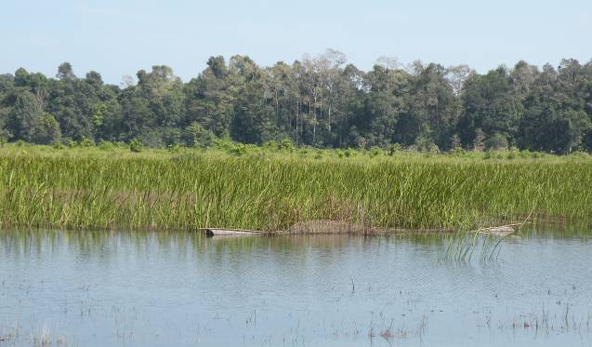
We asked the Park Director whether the communities have ever established a CPA on their own initiative and with the help of their own resources, and he replied negatively. Yet, we considered that in the past the local indigenous peoples (Kui) must have had their own rules for the management of natural resources. We tried to find out more about this, but the Reserve Director did not know much about local customs (he was from another region) and when we tried to meet with some elders in a local village, we were told that they were all busy away in their fields harvesting rice…. As a matter of fact there was hardly anyone left in the villages! We could only find out that two people are responsible for traditional village governance… and both of them were not home.
Photo 16: Tonle Mriec lake, O Por Village, Bung Per Wildlife Sanctuary, Kampong Thom Province

With the help of the guards of the reserve, we visited a sacred lake not far from the main road, which we were told the local villagers wish to protect as CPA. This is an important area for birds and gibbons, and still contains, right in the middle of the lake, the ruins of a very old temple (some say older than Angkor Wat). The lake was chosen by soldiers to camp near by during the civil war and the area is littered by bomb craters, remnants of the very heavy fights that took place there between the Vietnamese and the Khmer Rouge and earlier. People now go to the lake for recreation or to fish (several fish traps were visible).

We were told that the indigenous peoples who consider themselves caretakers of the lake and wish to establish there their CPA, have protected the lake from a group that wanted to build a pagoda right there. Having been unable to speak with anyone locally knowledgeable and reliable, we cannot guess what the local people need and wish to receive in terms of recognition and support to their ICCAs. Through the words of the Reserve Director, however, we heard that they wish to receive technical support to develop some eco-tourism operations, e.g. day visits, at the sacred lake.

Options for legal recognition and support to ICCAs in Cambodia
Throughout the world, recognition and support to conservation by indigenous peoples and local communities— and to ICCAs in particular— is fraught with difficulties related to policy, and problems related to implementation and practice. The situation in Cambodia is no exception, although our brief survey and analysis points to some unexpected reasons for hope and some rather clear paths for action.

Current protected area legislation in Cambodia calls for the active participation of indigenous peoples and local communities in conservation, and states that traditional rights need to be respected in forestry activities. This is an excellent beginning. But indeed there is still room to develop feasible and agile mechanisms to respond in practical ways to this legislation and the obligations of Convention on Biological Diversity (of which Cambodia is a member state).

It seems to us that security of land and resource tenure combined with respect for the existing customary institutions and, as necessary, some tailored forms of support, responding to the specificities of the context, are the ground on which the engagement in conservation of indigenous peoples and local communities can be most effectively developed. In close consultation with Cambodian professionals, we have identified a number of policy options that appear feasible and potentially interesting. Our goal here is not to identify “one” or “the best” such option, but to list and compare them for decision makers and local actors, and thus further reflection and action on these.

Perhaps as a first step, common to all options, is to identify the ICCAs that still exist in Cambodia. Following straightforwardly from the country’s international obligations under the CBD, the Ministry of Environment and the Forest Administration and Fisheries Administration could ask some technically competent NGOs or civil society organisation – possibly even in association with international bodies dedicated to ICCAs – to produce a national inventory of ICCAs in Cambodia. ICCAs can be either nested inside the PA system (and thus under the jurisdiction of the Ministry of Environment) or cover land, forests and waterways outside the PA system (and thus under the Forest and Fisheries Administrations). Obviously, they are also in all cases under some provincial and local administrations. As ICCAs have performed and continue to perform crucial roles, the competent ministries and provincial/ local authorities could argue that they should be “recognised” by the state as areas that provide crucial conservation and livelihood benefits. As such, they could or not be included in the national PA system, but should in all cases be “secured” under community governance and protected from external threats. In particular, lessons learned so far show that communities should acquire security of tenure on their ICCAs without being imposed any new institutions or regulations on top of their existing, customary ones, which have generally stood the test of time.

During our recent visit to a number of Cambodian ICCAs, we came across a few possible “options for recognition” that are already fully available under current legislation and rules, or that could be made available through relatively minor modifications. The situations we encountered and the specific options for recognition that they spelled out for us are described in Table 1 below.

Table 1. Options for the official recognition of ICCAs in Cambodia

specific situation | option | Relevant arrangement, policy and rules
Clearly identified ICCAs inside one of the 23 existing Protected Areas in the country (and thus legally under the jurisdiction of the Ministry of the Environment) | No. 1 | As part of the protected area zoning process, areas can be identified where communities can continue to reside and engage in agriculture (the so-called “Community Zones”) and areas where communities can continue to collect forest products, comprising Community Protected Areas (CPAs) and sustainable use zones. It is possibly symptomatic of the current mistrust and misunderstanding of communities and ICCAs that, despite the name, existing CPAs generally overlook and leave outside of their demarcation the strictly conserved “sacred forests” that communities continue to monitor, patrol and defend on a voluntary basis. In this sense, this “option” would imply a revision of the PA zoning, with consequent inclusion of the ICCAs as part of a CPA and/or a Community Zone. In the latter case, it should be specified that the ICCA areas and resources are strictly under common management right (or, wherever possible, title), and they cannot be subdivided or individually adjudicated for any reason. Any protected area that recognises ICCAs within itself should also devise an overall shared governance regime, whereby the institutions governing the ICCAs are represented in the bodies governing the PA.
Clearly identified ICCAs outside any of the 23 existing Protected Areas in the country (and thus legally under the jurisdiction of the Ministry of Agriculture, Fisheries and Forestry) | No. 2 | For ICCAs not included in a protected area, official recognition could involve a simple procedure to add an extra layer of legal protection and security to the customary rules community institutions would continue to enforce. The legal protection would be exercised with the support of agents of the Forest and Fisheries Administrations and in collaboration with provincial and communal authorities, but in all cases under the specific guidance and request of the concerned community. The main scope of the recognition would be to provide the community with better security of tenure and punctual support to fend off threats to their ICCAs. The areas and resources would be registered as an ICCA under common management right (or, whenever possible, common title); they could not be subdivided or individually adjudicated for any reason. The management plan for the ICCA would remain under the control of the community institution in charge, which would request – as necessary – on going technical support from the Forest or Fisheries Administrations.
Clearly identified ICCAs outside any of the 23 existing Protected Areas in the country (and thus legally under the jurisdiction of the Ministry of Agriculture, Fisheries and Forestry) | No.3 | Another option for ICCAs outside the Protected Areas in the country would be for well-organised communities, possibly supported by NGOs or other agencies, to request their provincial or municipal governments to declare their ICCAs as “provincial/ municipal protected areas or forests” and – simultaneously – request to be set in charge of their management, for instance through relatively long-term leases. Achieving this would demand specific alliances with local agencies and politicians that could prove difficult and most likely unaffordable by all the communities in need. In addition, this would need to be confirmed by a government sub-decree. For some special, high-profile ICCA, however, this pathway could ensure that the communities maintain the ICCA under their own control under the wing of their provincial authorities.

The only situations that fall outside the ones mentioned above include cases where the identification of ICCAs is not clear and/or the land and resources have been already adjudicated under private property or private concessions. To resolve such cases, a court of jurisdiction could be identified where communities could re-vindicate their customary affiliation and rights and argue for the ICCA to be conserved under their stewardship.

A promising way to recognise clearly identified ICCAs under the jurisdiction of the Ministry of Agriculture, Forestry and Fisheries and set option 2 to work would be to develop and apply a modified version of the Community Forestry Regulations that currently regulates Community Forests (CFs). Such regulations would define a “Community Patrimony Forest” (CPF) -- or “Community Patrimony Land” (CPL) or “Community Patrimony Water Body” (CPWB) -- where the term “community” would encompass all the people who recognise a common patrimony in the concerned natural resources. As for CFs, CPFs, CPLs or CPWBs would be leased by the competent government administration to the concerned community, and the process could involve a number of steps:

Step 1. The community maps and demarcates its “common patrimony” (spirit forest, sacred lake, sacred spring, ancient transhumance corridor, etc.) in collaboration with other communities that also traditionally visit, respect and value the same land and resources. No limit would be imposed a priori on the total area that can be demarcated but the concerned Ministries and administrations (e.g., the Forest and Fishery Administrations of the Ministry of Agriculture, Forestry and Fisheries, etc.) as well as provincial and communal authorities may wish to consider proofs of the ancestral affiliation of the community with the natural resources at stake, such as presence of burial sites, cultural features and evidence of ceremonial practices and stories, excellent state of conservation of natural resources including presence of wild species not found in surrounding areas, clear borders, clear different “appearance” of the area with respect to its surroundings; confirmation coram populi, etc.).

Step 2. The community agrees to maintain in place the traditional governance/ management system, comprising the institutions, values and rules that succeeded in conserving their natural and cultural patrimony so far, in particular regulations concerning tree cutting and commercial uses of natural resources.

Step 3. The community agrees to clarify, compile and, if necessary, strengthen its regulations concerning the governance and management of the patrimony (CPF, CPL or CPWB), in particular with regard to disturbances and extraction of wildlife (plants and animals) and to ways of dealing with new conditions and threats, to ensure their long-term conservation. If the traditional institutions are composed of illiterate elders, the regulations could be tape-recorded. Alternatively, the relevant people could be assisted by literate people of their choice to compile the regulations and share them with the concerned Ministries. As part of this, and upon negotiation with the government authorities, the community may be asked and be willing to accept some restriction of use or banning of specific practices, which could provide the government with a desired assurance of conservation values through time.

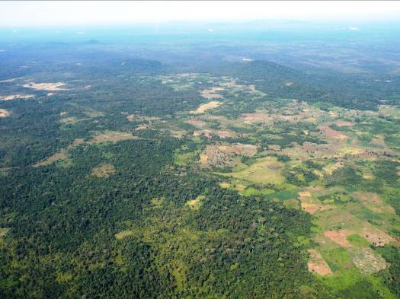
Step 4. Under the overall coordination of the Ministry of Agriculture, Forestry and Fisheries, all concerned Ministries, provincial and communal authorities agree to recognise the community institution and regulations and to assist the community to protect its CPF or CPWB from undesired outside interference. The relevant Ministries formally assign to the community the common right to manage its CPF, CPL or CPWB under a lease contract of 30 years, automatically renewed if the community demonstrates its capacity to conserve the patrimony at stake (indicators and assumptions are specified at the beginning of the lease.) All this is specified as part of a Patrimony Agreement between the concerned communities and Ministries.
Photo 16: 17: The landscape of northeastern Cambodia

It is important to notice here that, with respect to the CF Agreements specified by the Sub-decree on Community Forestry Management of 2003, a Patrimony Agreement should be much less directive, more flexible and open. It should leave to the concerned community the specifics of governance structures and management plans while concerning the government administration only with providing technical support upon request and carrying out periodic monitoring and evaluation activities in close collaboration with the concerned communities. In other words, given the particular nature of Patrimony land and resources, sensible latitude should be left to the concerned indigenous peoples and local communities to keep relating to them in their own customary ways. Only the end goals freely agreed as part of the relevant Patrimony Agreement and spelled out through specific indicators and assumptions should be carefully monitored and evaluated as the basis upon which the agreement would be, or not, renewed.

Conclusions and recommendations
As exemplified by the cases briefly described above, the current situation of ICCAs in Cambodia is various, complex and extremely fluid. We are tempted to write the banality that “every ICCA is unique and demands a tailored solution”. More concretely, what we could envisage in support to the communities motivated to conserve, govern and manage their bio-cultural patrimonies is that the country explores as soon as possible a set of options for the official recognition of ICCAs. Among such options, the concerned communities could chose according to their specific circumstances (e.g., within or outside a protected area).

In general, however, and on the basis of experience accumulated all over the world, we must say that all options for the official recognition of ICCAs should possess some desirable characteristics. These characteristics, which have been strongly confirmed by the results of our rapid survey of cases in Cambodia, are listed in Table 2, below.

Table 2: Desirable characteristics of an officially recognised ICCA

- An ICCA should be a territorial unit, governed and managed as a unit by a well-defined community.
- The concerned community should be – as far as possible – naturally constituted and relatively small (e.g. a village rather than a “rural commune” or municipality”).
- The ICCA should be governed by the concerned community under a form of common tenure (common property by the concerned community is best; government property under community long-term lease is also acceptable).
- The ICCA regime should be such that the land and resources could not be sold, in totality or in part, nor otherwise subdivided and appropriated for private benefits.
- The ICCA should be maintained under the governance of the traditional institutions that established it and ruled over it under customary law, supported – as necessary – by others of their own choice (e.g., literate local youth to interact with government authorities in written form; technical staff with specific competences; etc.).
- The ICCA should not be externally regulated or evaluated in terms of process and structures (e.g., rules to set up a management committee, develop a management plan, etc.) but in terms of outputs and impacts for both conservation and livelihoods for the concerned communities.
- As necessary, the ICCA could be jointly monitored and evaluated by the concerned communities and government administrations, with a view at problem solving and constructive support.

In light of the above, we recommend that all the national agencies, NGOs and supporting organisations concerned with bio-cultural diversity in Cambodia join hands and set up as soon as possible a set of parallel “pilot initiatives” to implement different options for the formal recognition of ICCAs in Cambodia. These initiatives – which would include the implementation of options 1 to 3 described in Table 1 above -- could be set out in an experimental mode and provide concerned communities with a form of common tenure to their ICCAs, with an emphasis on learning from the experience. As part of all such pilot initiatives, some forms of support could also be provided upon the explicit request of the concerned communities. We estimate that such support may need to focus on technical assistance (e.g., legal advice, support to negotiate, support to organise among communities, provision of information, impact studies or even assistance to establish agreements with private companies who acquired concession rights over ICCAs) and security (support to repress infractions to the local rules by inside and outside actors) as these are the kinds of support most often discussed and requested in the sites we visited.

The pilot initiatives would constitute crucial “learning sites” for future policy decisions for the country. They would help identifying the pros and cons of different legal/ policy choices, could experiment and test the “desirable characteristics” listed in Table 2, among others, and would bring to light any eventual need for accompanying support. Ideally, the initiatives would be set out as part of a national learning network, with focal point persons based in all the pilot sites. The network would ensure the on-going monitoring, evaluation and participatory discussion of the process of “implementing the options” as well as of their results and impacts. Particular care would be taken in monitoring ecological and socio-cultural indicators unique to each case and adopted option. Through the learning network, results would be assessed and compared in a timely manner, and lessons would be drawn to feed the development of improved policy, legislation and practice in the country.

We strongly recommend the competent authorities and supporters to establish the mentioned pilot initiatives and national learning network as rapidly as possible, and to foresee as its main output well-grounded advice and policy recommendations for the Cambodian government. This would fully respond to the directives of the CBD Programme of Work on Protected Areas, CBD COP 9 Resolutions and obligations under the UN Declaration on the Rights of Indigenous Peoples, of which Cambodia is a signatory country. By so doing Cambodia would also help secure its bio-cultural jewels— indeed an action whose time has come!

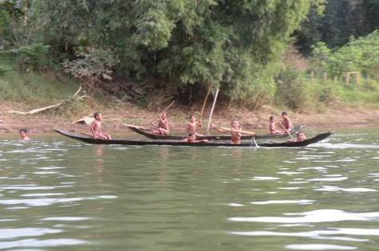
Acknowledgement
Our warmest thanks to the villagers and protected area staff who welcomed us in the three Cambodian provinces visited in November 2009. With them, the authors would sincerely like to acknowledge the great help and advice of the people who made this study possible, in particular Mr. Ken Serey Rotha of the Ministry of Environment, Mr. Serey Rona of the CBNRM Learning Institute, Ms. Hou Kalyan of RECOFTC and Mr. Van Son, in Ratanakiri Province. Warm thanks also to Ashish Kothari, who read and commented an earlier version of this paper. Dr. Borrini-Feyerabend received partial travel and accommodation support during her visit thanks to the IUCN Commission on Environmental, Economic and Social Policy (CEESP), which is most gratefully acknowledged. Both authors received travel support to the Kok Lak Commune as part of a gathering of the Co-management Learning Network in South East Asia – managed by AIPP – to which they are both affiliated. All the pictures in this paper are by Grazia Borrini-Feyerabend.
Photo 18: Boys playing along the Lalay river, Ratanakiri Province.

References
Brown, D. and K. Schreckenburg, 1998. Shifting cultivators as Agents of Deforestation: Assessing the Evidence, Natural Resources Perspectives no.29, Overseas Development Institute, London.
Bonnefoy, Y. 1991. Asian Mythologies, University of Chicago Press, Chicago (IL).
Borrini-Feyerabend, G., A. Kothari and G. Oviedo. 2004. Indigenous and Local Communities and Protected Areas: Towards equity and enhanced conservation, Best Practice Protected Area Guidelines Series No. 11., IUCN Gland (Switzerland) and Cambridge (UK).
BPAMP (Biodiversity and Protected Areas Management Project), 2002 (manuscript). Participatory Rural Appraisal. Natural Resource Use in O Chay Watershed, O Chay, Titiam and Kiribasleu villages. Santepheap Commune, Siem Pang District, Stoeung Treng province, Ban Lung, Ratanakiri, Cambodia, 41 pp +.
Bottomley, R. 2000. Structural Analysis of Deforestation in Cambodia (with a focus on Ratanakiri Province, Northeast Cambodia). Non-Timber Forest Products Project for Mekong Watch and Institute for Global Environmental Strategies of Japan, Ban Lung, Ratanakiri (Cambodia), 37 pp.
CHRAC (Cambodian Human Rights Action Committee), 2009. Losing Ground: Forced Evictions and Intimidation in Cambodia, Phnom Penh.
De Jong, W. 1997. “Developing Swidden Agriculture and the Threat of Biodiversity Loss”, Agriculture, Ecosystems and Environment 62:187-197.
Dearden, P., S. Chettamart, D. Emphandu and N. Tanakanjana 1996. “National Parks and Hill Tribes in Northern Thailand: A Case Study of Doi Inthanon”. Society and Natural Resources 9: 125-141.
Dove, M. R. 1983. “Theories of swidden agriculture and the political economy of ignorance”. Agroforestry Systems 1(1): 85-99.
Dove, M. R. 1993. “A revisionist view of tropical deforestation and development”. Environmental Conservation 20(1): 17-56.
Ducourtieux, O. 2000. Agriculture and Deforestation in Laos; the machete: an alibi for the chain saw?, Rural Development Project of Phongsaly District, Committee of Co-operation with Laos, Laos.
Dudley, N. (ed.). 2008. Guidelines for Applying Protected Area Management Categories, WCPA and IUCN Gland (, Switzerland)
Fairhead, J. and Leach, M. 1996. Misreading the African Landscape. Cambridge University Press, Cambridge (UK).
Fox, J., D. McMahon, M. Poffenberger and J. Vogler, 2008. Land for My Grandchildren: Land Use and Tenure Change in Ratanakiri: 1989-2006. Community Forestry International and the East West Center.
Fox, J., 1998. Mapping a Changing Landscape: Land Use, Land Cover and Resource Tenure in Northeastern Cambodia. Programme on Environment, East-West Centre, Honolulu.
Fox, J., D.M. Truong, A.T. Rambo, N. P. Tuyen, L.T. Cuc, and S. Leisz, 2000. “Shifting Cultivation: A New Old Paradigm for Managing Tropical Forests”. BioScience 50(6):521-528.
Gómez-Pompa, A., and A. Kaus, 1992. “Taming the Wilderness Myth: Environmental Policy and Education are based on Western beliefs about Nature rather than on Reality”, Bioscience 42(4):271-279.
Hirsch, P. 2000. “Underlying causes of deforestation in the Mekong Region”, report presented at regional workshop on Forest Management Strategies in the Mekong Region, NUOL, Vientiane.
Ironside, J. and R. Ken Serey, 2005. An Overview of the Status of Indigenous People and Protected Areas in Cambodia. AIPP and FPP, Chiang Mai (Thailand).
Ironside, J. and I.G., Baird, 2003. Wilderness or Cultural Landscape: Settlement, Agriculture, and Land and Resource Tenure in Virachey National Park, Northeast Cambodia. Biodiversity and Protected Areas Management Project, Ministry of Environment/World Bank, Ban Lung, Ratanakiri (Cambodia).
IUCN/CEESP, 2008. Recognising and supporting indigenous & community conservation— ideas & experiences from the grassroots, Briefing Note no.9.
IUCN/WCPA, 2006. Special issue on Community Conserved Areas, Parks Vol 16 No 1.
Kim S. (ed.), 2001. Participatory Rural Appraisal: Natural Resources Use in the Watershed Area, along Tabok Stream, O’ Tabok and Bang Village, Taveng Leu Commune, Taveng District, Ratanakiri. Biodiversity and Protected Areas Management Project, Ministry of Environment, Ban Lung, Ratanakiri (Cambodia).
Kim S, 2000. Park Wide Assessment (Draft). Virachey National Park, Ratanakiri. Community Development Component, Biodiversity and Protected Areas Management Project, Ban Lung, Ratanakiri (Cambodia).
Kingdom of Cambodia, 2003. Sub-decree on Community Forestry Management.
Kingdom of Cambodia, 2008. Protected Area Law.
Kleinman, P., R. Bryant and D. Pimental, 1996. “Assessing Ecological Sustainability of Slash and Burn Agriculture through Soil Fertility Indicators”. Agronomy Journal 88: 122-127.
Kothari, A. 2009. "Protected areas and people: the future of the past", Parks, 17: 2: pages 23-34.
Leuprecht, P. (Special Representative of the Secretary-General for human rights in Cambodia) 2004. Land concessions for economic purposes in Cambodia: A human rights perspective. United Nations Cambodia Office of the High Commissioner for Human Rights, Phnom Penh.
NGO Forum on Cambodia, 2006. Land Alienation in Indigenous Minority Communities – Ratanakiri Province, Cambodia. Phnom Penh.
Royal Government of Cambodia, 2009. Sub-Decree on Procedures of Registration of Indigenous Communities, Unofficial English Translation, Ministry of Land Management, Urban Planning and Construction, Phnom Penh.
Royal Government of Cambodia, 2009. The Progress of Registration of Land as Indigenous Community as Collective Ownership in Cambodia. Ministry of Land Management, Urban Planning and Construction, Phnom Penh.
Steinmetz, R. 1996. “Landscape Ecology and Wildlife Habitats: An Indigenous Karen Perspective” in Thung Yai Naresuan. Wildlife Sanctuary of Western Thailand. Wildlife Fund of Thailand, Bangkok.

About the authors

Dr. Grazia Borrini-Feyerabend (gbf@cenesta.org) has been closely associated for 17 years with the International Union for the Conservation of Nature (IUCN). Among her various capacities with IUCN she has been Head of its Social Policy Programme, Vice-chair of its Commission on Environmental, Economic and Social Policy (CEESP) and Vice-chair of the World Commission on Protected Areas (WCPA). She is currently President of the Paul K. Feyerabend Foundation (www.pkfeyerabend.org), Vice Chair of CEESP for Europe, founding member of the ICCA Consortium (www.ICCAForum.org) and member of several governing and advisory bodies dealing with natural resources in various countries.

Jeremy Ironside (jeremyi@camintel.com) has lived and worked on and off in Cambodia since 1994, advising and consulting on community livelihoods, sustainable agriculture, community resource management, and land and tenure issues for indigenous communities in Ratanakiri province and in the Cardamom Mountains area. From 2005-2008 he coordinated a regional co-management learning network promoting dialogue between indigenous communities and protected areas in 7 countries in South East Asia. He is presently doing research into the impacts of land use and tenure change for indigenous communities in the northeast of Cambodia. He has been a CEESP member for nearly a decade.

http://cmsdata.iucn.org/downloads/recommendationen.pdf
http://www.cbd.int/protected/pow.shtml
http://www.un.org/esa/socdev/unpfii/documents/DRIPS_en.pdf
http://www.cbd.int/decision/cop/?id=11661
http://www.iucn.org/congress_08/assembly/policy/
Hirsch, 2000.
In the five years from 2000 to 2005 Cambodia was ranked as the country with the third worst rate of deforestation in the world (behind only Nigeria and Vietnam), losing 29.4% of its primary forests. Ref: R.A. Butler, www.mongabay.com, November 2005.
Bottomley, 2000; Leuprecht, 2004; CHRAC, 2009; NGO Forum, 2006; Fox et al., 2008.
Ironside and Ken Serey, 2005.
Dudley, 2008.
Borrini-Feyerabend et al., 2004.
Kothari, 2009.
.IUCN/WCPA, 2006.
Borrini-Feyerabend et al., 2004.
IUCN/CEESP, 2008.
Bonnefoy, 1991.
Dove, 1983 and 1993; Gómez-Pompa and Kaus, 1992; Kleinman et al., 1996; Stienmetz, 1996; Fairhead and Leach, 1996; De Jong, 1997; Fox, 1998; Brown and Schreckenburg, 1998; Fox et al., 2000; Ducourtieux, 2000.
Dearden et al., 1996 ; Kim, 2000 and 2001; BPAMP 2002.
Ironside and Baird, 2003.
The elder's name was Mr. Yik Bunma
Ironside and Baird 2003.
Some timber felling took place under Vietnamese occupation.
IDRC - International Development Research Center.
There is, however, talk about a company wanting to come in with the ominous intention to build a cable car to connect the lake to a near-by sacred hill.
Locally named Phnom Youl (Phnom means hill in Khmer language) or Phnim Yun, in Tamnpuen language.
The hill falls entirely within the administrative boundary of Yeak Laom Commune, even if the Pachon people have customary use rights.
Work was carried out in March/April 2009.
Villagers on the Yeak Laom side of the hill say that the price paid to the neighboring commune for some “kilometers” of land on the side of the hill in the 1960s was a horse, a female pig, a blanket, a piece of weaving, a jar of rice wine and a naan of money.
The Kreung people are, like the Kavet, another of the sub groups of the Brao ethnic group.
A hint of past cannibalistic practices in the area?
Seemingly, the wife of a powerful politician occupies an important position in the company that wants to mine this hill.
Under the Sub Decree on Procedures on Registration of Land of Indigenous Communities (2009), indigenous communities are entitled to claim a communal land title over the following areas of land: residential land, traditional agricultural land, actual cultivated land, farm land and reserve land necessary for shifting cultivation (recognised by administration authorities and neighbours), burial forest (not exceeding 7ha), spirit forest areas (not exceeding 7 ha).
Kulen is the Khmer name for lychee. Lychees and other wild fruits grow throughout the forests in this area and fruit is collected and sold both from within and outside the CPA areas.
“For communities living within or near the Permanent Forest Reserve, the State shall recognize and ensure their customary user rights for the purpose of traditions, customs, religion and livelihood as defined in this Article 40” [of the Cambodia Forestry Law].
An example is the ICCA Consortium (www.ICCAforum.org ).
Article 10 of current Protected Areas Law (Kingdom of Cambodia, 2008).
Kingdom of Cambodia, 2003.
Other relevant Ministries, such as the Ministry of Water Resources and the Ministry of Industry, Mines and Energy, may also need to be consulted but this needs to be further determined.
The Sub-decree on Community Forestry Management of 2003 foresees specific blueprint procedures for the definition of Management Committees, Forest Agreements and Forest Management Plans. This is completed by a set of Prakas Guidelines (implementation regulations) that are extremely detailed and rather constraining.
This does not exclude multiple or complex units.
But cases exist of effective joint governance by two or more communities

