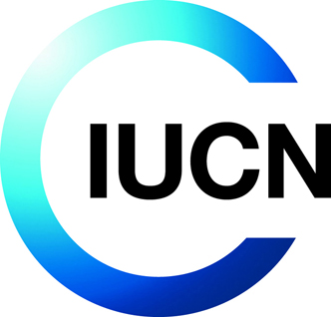
Heritage Heroes Award
Nomination

Please fill-in this form electronically, and email it to heritageheroes@iucn.org

Contacts
Please give contact information for the nomimee so we can get in touch with them if necessary
Name of nominee
(First name, surname)
Job title
(if applicable)
Address
Email address
Contact telephone

Natural World Heritage site(s)
Please list the natural sites where the nominee has contributed to

Criteria for selection
Please give a description for each criteria below
1. Self-starter
Someone who has led to a major initiative, beyond their normal job
(maximum 300 words)
2. Ground level
The actions must be focused at ground-level change, related to one or more natural World Heritage sites and the communities in and around them
(maximum 300 words)
3. Results
The actions taken show clear results in tackling an immediate threat or major issue, which ideally is evidenced in the IUCN World Heritage Outlook (maximum 300 words)
Note: For verification visit www.worldheritageoutlook.iucn.org. If an existing threat is not identified on the IUCN Outlook, please get in touch: worldheritageoutlook@iucn.org

Submitted by

First name, surname:
Email address:
Date:

