BRIDGE: Building River Dialogue and Governance
Mekong region: Sekong (Viet Nam-Lao PDR-Cambodia), Sesan river (Viet Nam-Cambodia), Sre Pok (Viet Nam-Cambodia)
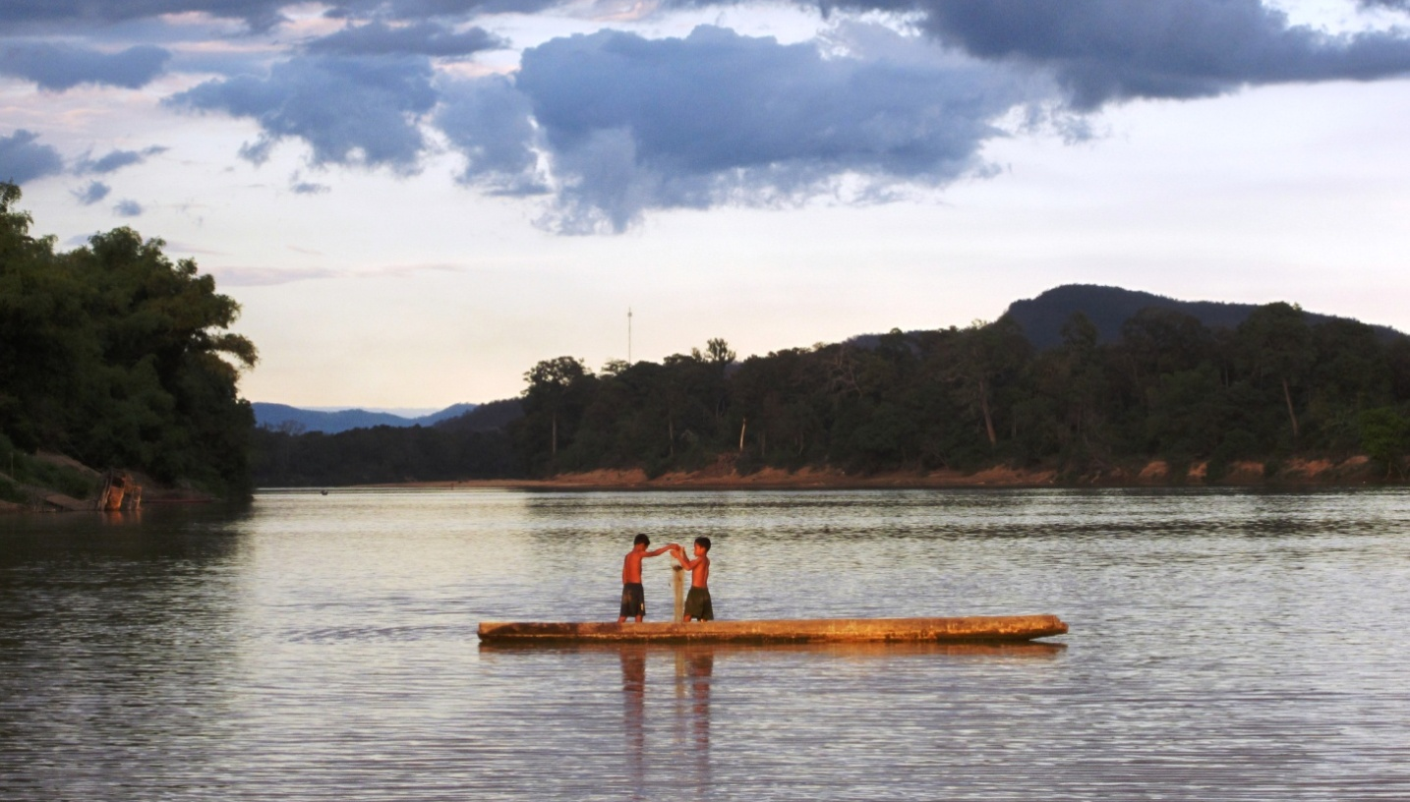

Context

The Sekong, Sesan and Sre Pok rivers of Cambodia, Lao PDR and Vietnam are the only trans-boundary tributaries of the Mekong. The 3S rivers – as they are collectively called – are instrumental in the hydrology of the Lower Mekong, contributing up to 18 percent of its annual total discharge.

The 3S river basin is also a breadbasket for the livelihoods of over 3 million people, many of whom depend directly on the rivers’ resources. As the Asian region develops, and considering the basin’s high irrigation and hydropower potential, the 3S rivers are expected to continue playing a significant role in the economic growth of the basin, and the region as a whole.
Our approach

Collaborative trans-boundary governance is central to the sustainable and efficient use of water management resources in the 3S river basin.

IUCN, under the umbrella of the Building River Dialogue and Governance (BRIDGE) project supported by the Swiss Agency for Development and Cooperation (SDC), seeks to facilitate cooperative processes in the 3S region, by developing and strengthening water governance capacities through governance reforms, stakeholder dialogues and knowledge exchange programmes.

What is water governance?

Water governance sets the ‘rules of the game’ for the way water is managed. It determines how, or even whether, sustainable water resource management is implemented. Poor water governance results in degradation and over-allocation of water resources, is a cause of vulnerability for poor people and loss of biodiversity, and leads to weaker and less resilient livelihoods and economic growth.

Water governance is organized according to policy, laws and institutions in a country. In trans-boundary basins, good water governance requires the countries sharing waters to cooperate.

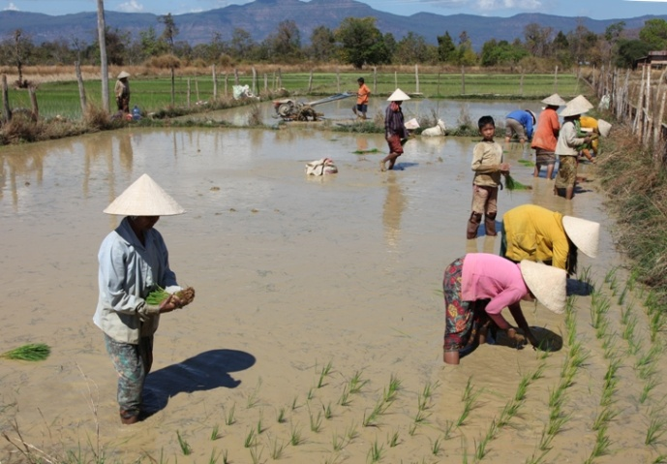

Objectives in the Mekong Region

Over the past two decades, the 3S river basin has seen a proliferation of human settlements, and with it, rapid social and economic growth. A suitable long term strategy to meet the needs of its growing population and the environment is needed to stem burgeoning pressures, and to ensure equal benefit sharing of river resources.

To promote a shared vision for sustainable use of water resources in the 3S river basin, IUCN is working towards achieving the following objectives:

Establishing frameworks for institutional arrangements and trans-boundary cooperation
As a preliminary approach to building a comprehensive road map for the 3S basin, a secretariat at the provincial level and appropriate organizations will be established in the Sekong river basin. Appropriate country-driven frameworks for institutional arrangements will be developed for the Sesan and Sre Pok river basins.

Enriching and fortifying knowledge sharing platforms
Data from situational analyses performed to fill in knowledge gaps will be consolidated into a basin profile and hosted within an accessible online database. Stakeholders can use this database as a knowledge resource hub.

Enhancing leadership and governance capacities
Training programmes on water resources management concepts, such as environmental flows and hydro-diplomacy will be offered to local leadership to encourage integrated water resources management and policy advocacy engagement.

The Global BRIDGE Project
The global BRIDGE project is implemented in 9 trans-boundary river basins:
- South America: Zarumilla river (Ecuador-Peru), Catamayo-Chira river (Ecuador-Peru), Lake Titicaca basin (Peru-Bolivia)
- Mesoamerica: Coatan river (Mexico-Guatemala), Goascoran river (Honduras-El Salvador), Sixaola river (Costa Rica-Panama)
- Mekong region: Sekong (Vietnam-Lao PDR-Cambodia), Sre Pok (Vietnam-Cambodia), Sesan river (Vietnam-Cambodia)

Publications
SHARE – Managing Water Across Borders NEGOTIATE – Reaching Agreements over Water RULE – Reforming Water Resource

The WANI toolkits can be downloaded from the IUCN Publications website:
www.iucn.org/knowledge/publications_doc

For more information, please contact:
Lalita Rammont, PhD
Programme Manager
E-mail: lalita.rammont@iucn.org

IUCN Water Programme, Asia
www.iucn.org/asia_water
www.3sbasin.org

